Appendix-II

Ref. No. UCVLLP/UBI/25-26/626 Date: 18/12/2025

VALUATION REPORT OF
MR. SANDEEP SUSHIL DROLIA
SHOP NO. 03, GROUND FLOOR, KAJAL HERITAGE CO-OPERATIVE HOUSING SOCIETY LTD., PLOT NO. 2A, SECTOR - 12D, KOPARKHAIRANE, NAVI MUMBAI, THANE - 400 709.
FOR
UBI, UMFB BRANCH

To,
The Branch Manager
Union Bank of India
UMFB Branch
VALUATION REPORT (IN RESPECT OF SHOPS)
I. | GENERAL
1. | Purpose for which the valuation is made
2. | a) | Date of inspection |  | :
 | b) | Date on which the valuation is made |  | :
3. | List of documents produced for perusal
 | - Agreement for sale
 | - Index II
 | - Occupancy Certificate
 | - Commencement Certificate
 | - Other Documents
4. | Name of the owner(s) and his / their address (es) with Phone no. (details of share of each owner in case of joint ownership) |  |  | : | Name of the Owner: -  Ownership –
5. | Brief description of the property |  |  | : | Accommodation:  Amenities  Areas:
6. | Location of property
 | a) | Plot No. / Survey No. |  | :
 | b) | Door No./ Shop No. |  | :
 | c) | T. S. No. / Village |  | :
 | d) | Ward / Taluka |  | :
 | e) | Mandal / District |  | :
 | f) | Date of issue and validity of layout of approved map / plan |  | :
 | g) | Approved map / plan issuing authority |  | :
 | h) | Whether genuineness or authenticity of approved map / plan is verified |  | :
 | i) | Any other comments by our empaneled valuers on authentic of approved plan |  | :
7. | Postal address of the property
8. | City / Town |  |  | :
 | Residential Area |  |  | :
 | Commercial Area |  |  | :
 | Industrial Area |  |  | :
9. | Classification of the area |  |  | :
 | i) | High / Middle / Poor |  | :
 | ii) | Urban / Semi Urban / Rural |  | :
10 | Coming under Corporation limit / Village Panchayat / Municipality |  |  | :
11 | Whether covered under any State / Central Govt. enactments (e.g., Urban Land Ceiling Act) or notified under agency area / scheduled area / cantonment area |  |  | :
12 | Boundaries of the property |  |  | : | As per Site |  | As per Shops
 | North |  |  | :
 | South |  |  | :
 | East |  |  | :
 | West |  |  | :
13 | Dimensions of the site |  |  | : | A |  | B
 |  |  |  |  | As per Deed |  | Actuals
14 | Extent of the site |  |  | :
14.1 | Latitude, Longitude & Co-ordinates of Shop
15 | Extent of the site considered for valuation (least of 13 A & 13 B) |  |  | :
16 | Whether occupied by the owner / tenant? If occupied by tenant, since how long? Rent received per month. |  |  | :
II. | APARTMENT BUILDING
1. | Nature of the Apartment |  |  | :
2. | Location |  |  | :
 | C.T.S. No. |  |  | :
 | Block No. |  |  | :
 | Ward No. |  |  | :
 | Village/ Municipality / Corporation |  |  | :
 | Door No., Street or Road (Pin Code) |  |  | :
3. | Description of the locality Residential / Commercial / Mixed |  |  | :
4. | Year of Construction |  |  | :
5. | Number of Floors |  |  | :
6. | Type of Structure |  |  | :
7. | Number of Dwelling units in the building |  |  | :
8. | Quality of Construction |  |  | :
9. | Appearance of the Building |  |  | :
10 | Maintenance of the Building |  |  | :
11 | Facilities Available:
 | Lift |  |  | :
 | Protected Water Supply |  |  | :
 | Underground Sewerage |  |  | :
 | Car Parking - Open/ Covered |  |  | :
 | Does Compound wall exist? |  |  | :
 | Is pavement laid around the building |  |  | :
III | SHOP:
1 | The floor on which the Shop is situated |  |  | :
2 | Door No. of the Shop No. |  |  | :
3 | Specifications of the Shop |  |  | :
 | Roof |  |  | :
 | Flooring |  |  | :
 | Doors |  |  | :
 | Windows |  |  | :
 | Fittings |  |  | :
 | Finishing |  |  | :
4 | House Tax |  |  | :
 | Assessment No. |  |  | :
 | Tax paid in the name of |  |  | :
 | Tax amount |  |  | :
5 | Electricity Service Connection no. |  |  | :
 | Meter Card is in the name of |  |  | :
6 | How is the maintenance of the shop? |  |  | :
7 | Sale Deed executed in the name of |  |  | :
8 | What is the undivided area of land as per Sale Deed? |  |  | :
9 | What is the plinth area of the Shop? |  |  | :
10 | What is the floor space index (app.) |  |  | :
11 | What is the Carpet Area of the Shop? |  |  | :
12 | Is it Posh/ I class / Medium / Ordinary? |  |  | :
13 | Is it being used for Residential or Commercial purpose? |  |  | :
14 | Is it Owner-occupied or let out? |  |  | :
15 | If rented, what is the monthly rent? |  |  | :
IV | MARKETABILITY
1 | How is the marketability? |  |  | :
2 | What are the factors favouring for an extra Potential Value? |  |  | :
3 | Any negative factors are observed which affect the market value in general? |  |  | :
V | Rate:
1 | After analysing the comparable sale instances, what is the composite rate for a similar Shop with same specifications in the adjoining locality? |  |  | :
2 | Assuming it is a new construction, what is the adopted basic composite rate of the Shop under valuation after comparing with the specifications and other factors with the Shop under comparison (give details). |  |  | :
3 | Break - up for the rate |  |  | :
 | i) |  | Building + Services | :
 | ii) |  | Land + Others | :
4 | Guideline rate obtained from the Registrar's office (evidence thereof to be enclosed) |  |  | :
VI | COMPOSITE RATE ADOPTED AFTER DEPRECIATION
a. | Depreciated building rate |  |  | : |  | --
 | Replacement cost of Shop with Services (v (3)i) |  |  | :
 | Age of the building |  |  | :
 | Life of the building estimated |  |  | :
 | Depreciation percentage assuming the salvage value as 10% |  |  | :
 | Depreciated Ratio of the building |  |  | :
b. | Total composite rate arrived for valuation
 | Depreciated building rate VI (a) |  |  | :
 | Rate for Land & other V (3) ii |  |  | :
 | Total Composite Rate |  |  | :
Details of Valuation:
Sr. No. | Description | Built Up Area/  sq. ft. | Rate per unit Rs. | Estimated Value Rs.
1 | Present value of the Shop No. 03 | 274 | Rs. 32,000/- | 87,68,000/-
2 | Double Height Terrace area | -- | -- | Nil
2 | Wardrobes | -- | -- | Nil
3 | Showcases | -- | -- | Nil
4 | Kitchen Arrangements | -- | -- | Nil
5 | Superfine Finish | -- | -- | Nil
6 | Interior Decorations | --- | --- | Nil
7 | Electricity deposits / electrical fittings, etc., | -- | -- | Nil
8 | Extra collapsible gates / grill works etc., | -- | -- | Nil
9 | Potential value, if any | -- | -- | Nil
 | Total Value |  |  | Rs. 87,68,000/-
 | Total Say Value |  |  | Rs. 87,70,000/-

As a result of my appraisal and analysis, it is my considered opinion that the present fair market value of the above property in the prevailing condition with aforesaid specifications is Say Value Rs. 87,70,000/-
(Rupees Eighty-Seven Lakh Seventy Thousand Only)

i) | Fair Market Value of immovable property
ii) | Realizable value (95% of Fair Market Value)
iii) | Distress value (80% of Fair Market Value)
iv) | Guideline Value (value as per Circle Rates), if applicable, in the area where immovable property is situated
v) | Insurance Value
vi) | Date of purchase of immovable property:
vi) | Purchase Price of immovable property:

For Universal Consultants & Valuers LLP



(MANOJ KUMAR SHARMA)
B.E (Civil), F.I.V., M.I.E
Date: - 18/12/2025 Govt. Valuer & Chartered Engineer
Place: - Thane Panel Valuer of Union Bank of India
(IBBI/RV/07/2019/11044)

 | VALUATION METHODOLOGY: Sales Comparable Method
 | Comparative Method of Valuation: In this method, value of the recent sale prices of comparable properties in the vicinity, adjust difference in size, shape, location and other features. This method market and transaction prices are easily available.  Factors Affecting Valuation of the property |  | property is estimated by analyzing the prices to account for any is useful where there is an active
 | - Location  - Usage  - Frontage and Depth | - Return Frontage  - Accessibility  - Infrastructure & Development | - Vastu  - Encumbrances  - Special Advantages
The undersigned has inspected the property detailed in the Valuation Report dated on 18/12/2025. We are satisfied that the fair and reasonable market value of the property is Rs. 87,70,000/- (Rupees Eighty-Seven Lakh Seventy Thousand Only)

Branch Manager/Officer-in-Charge of Advance Department
Date

For Universal Consultant & Valuer LLP



(MANOJ KUMAR SHARMA)
B.E (Civil), F.I.V., M.I.E
Date: - 18/12/2025 Govt. Valuer & Chartered Engineer
Place: - Thane Panel Valuer of Union Bank of India
(IBBI/RV/07/2019/11044)

Remark
- Report finalized based on site visit and copy of: Sale Agreement, OC, Index II, Old Index II, Title Certificate, Typical Floor Plan, etc. However, we have not been provided with CC, Approved Plan, Electricity Bill, Maintenance Bill, etc. for verification purpose.
- The said property is situated in a Residential cum Commercial area.
- Shop no. 03 is internally merged with shop no. 02 & 04 with a single entrance from shop no.3.
- The said shop is Self-occupied at the time of visit.
- Property is inspected as shown by the person of site Mr. Bhupesh Singh (BCA).
- We consider the area given in the Agreement/Index II declared by the party and submitted for registration with the government authorities as final for valuation purposes. Any area that is not stated in the Agreement/Index II is not considered for valuation unless the area is measured by us in which case that may be considered for valuation purpose.
- The scope of our valuation work is only for banks financial/loan purposes. Further, please note that this report shall not be used for any litigation purpose.
- Encumbrance of Loan, Government and other dues, stamp duty, registration charges, transfer charges etc., if any are not considered in the valuation. We assume that the assets are free from encumbrance unless otherwise stated to us by the party in writing.
- The value given in our report is the estimate of the Fair Market value of the property as on date, considering various aspects of the property as mentioned above.
- The value given in the report is the estimate of the Fair Market value of the property as on date, considering various aspects of the property like amenities in projects, locational advantages, demand and supply equation, interior designing done in the property, outside view, Vashtu aspects etc. which is generally more than the Government ready reckoner value.
PHOTOGRAPHS OF THE PROPERTY
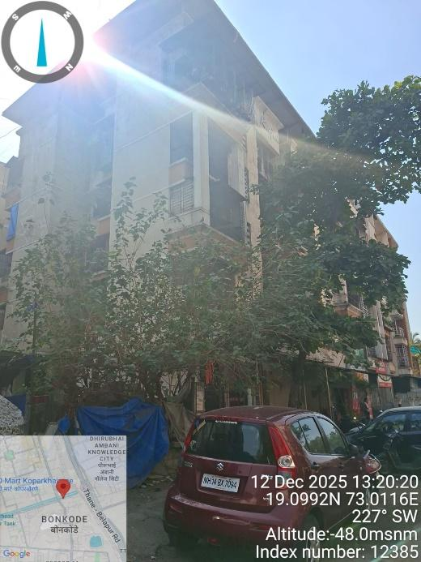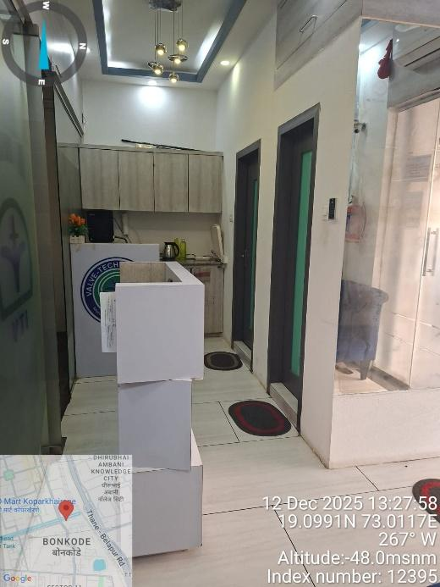

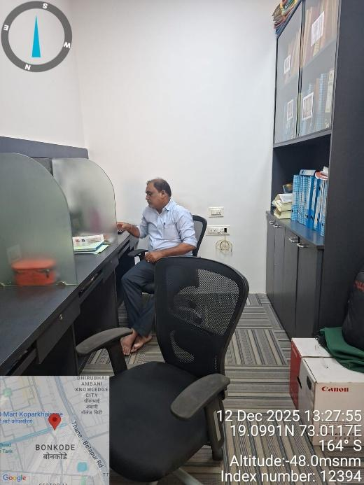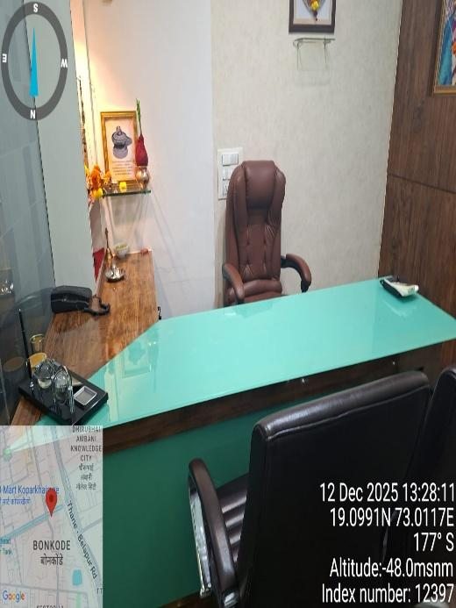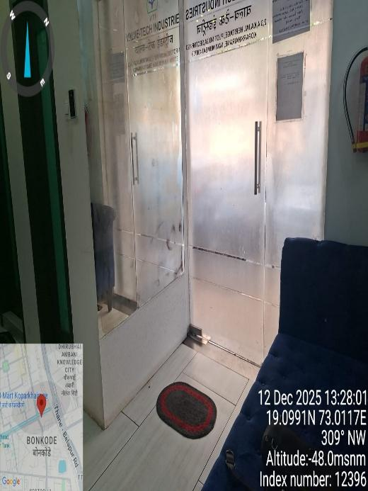

Stamp Duty Ready Reckoner for year 2025-2026
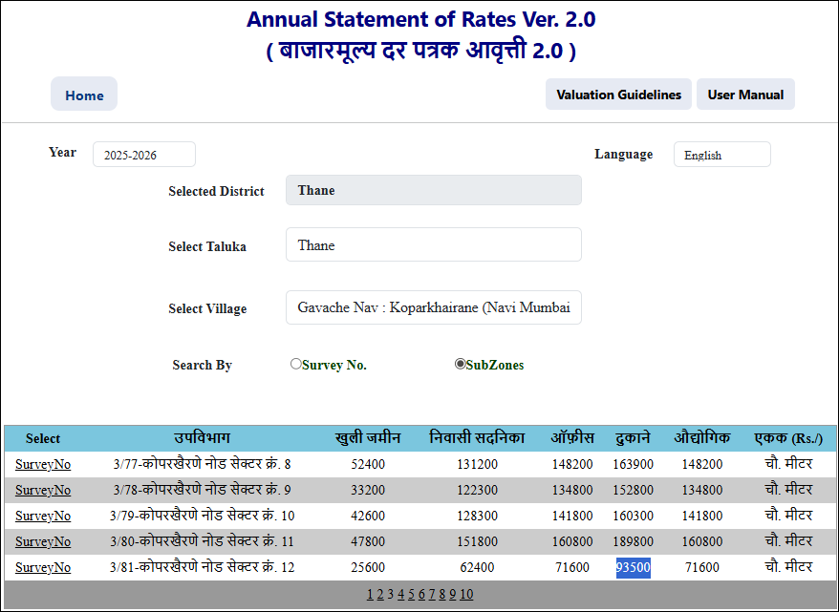

Location Map
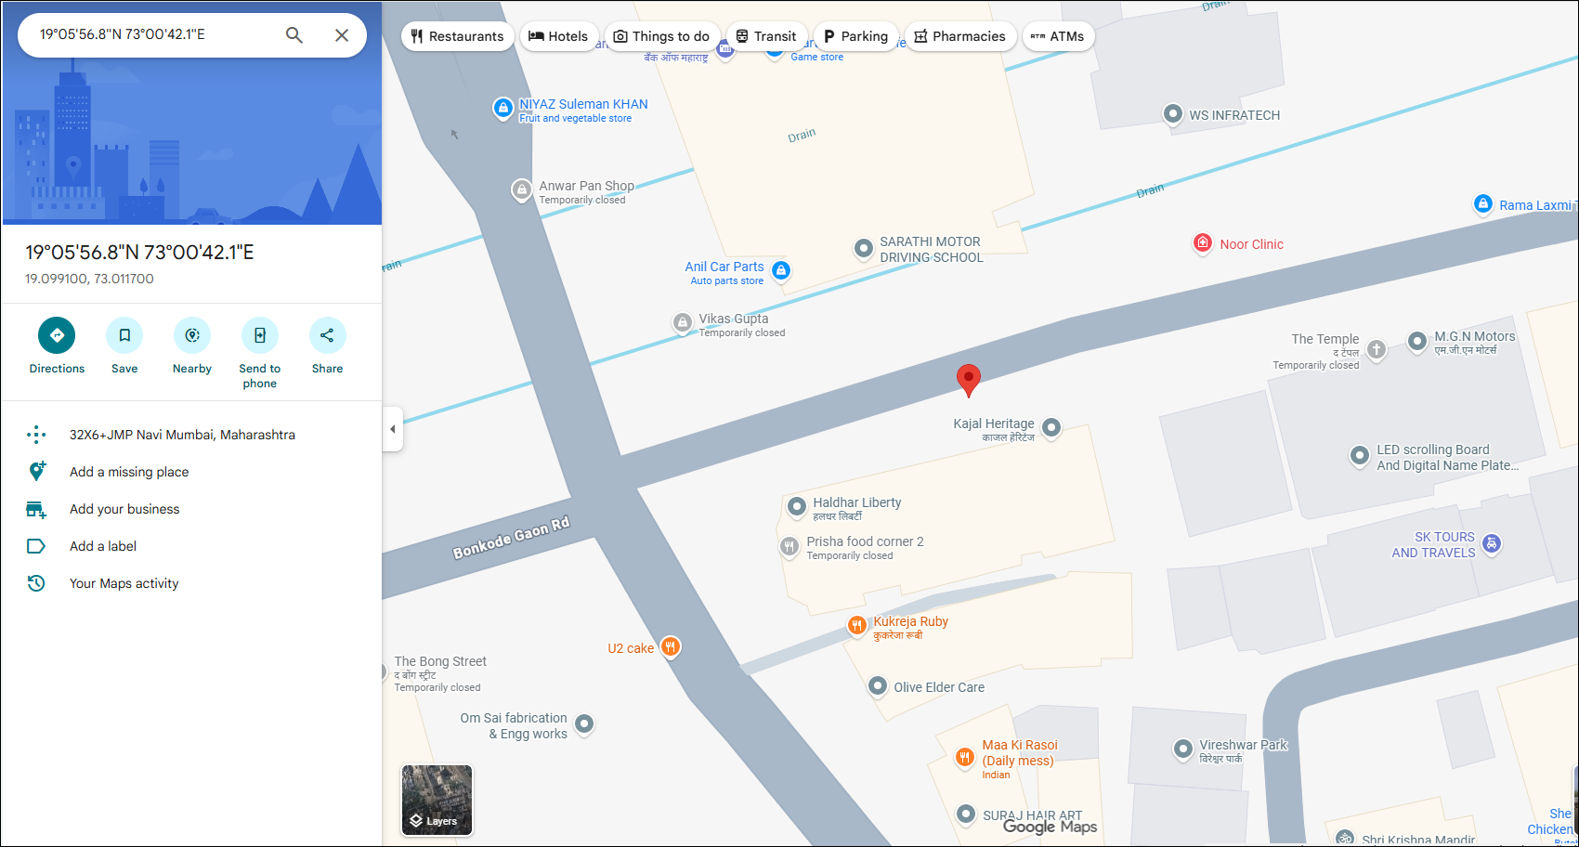
DECLARATION FROM VALUERS
I, hereby declare that:
- The information furnished in my valuation report dated 18/12/2025 is true and correct to the best of my knowledge and belief and I have made an impartial and true valuation of the property.
- I have no direct or indirect interest in the property valued.
- Our Engineer Mr. Rajesh Kolkundy has inspected the property on 12/12/2025.
- I have not been convicted of any offence and sentenced to a term of Imprisonment.
- I have not been found guilty of misconduct in my professional capacity.
- I have read the Handbook on Policy, Standards and procedure for Real Estate Valuation, 2011 of the IBA and this report is in conformity to the "Standards" enshrined for valuation in the Part - B of the above handbook to the best of my ability.
- I have read the International Valuation Standards (IVS) and the report submitted to the Bank for the respective asset class is in conformity to the "Standards" as enshrined for valuation in the IVS in "General Standards" and "Asset Standards" as applicable. The valuation report is submitted in the prescribed format of the bank.
- I abide by the Model Code of Conduct for empanelment of valuer in the Bank. (Annexure III - A signed copy of same to be taken and kept along with this declaration)
- I am Chairman & Managing Director of the company, who is competent to sign this valuation report.
- Further, I hereby provide the following information.
Sr. No. | Particulars | Valuer comment
 | Background information of the asset being valued;
 | Purpose of valuation and appointing authority
 | Identity of the valuer and any other experts involved in the valuation;
 | Disclosure of valuer interest or conflict, if any;
 | Date of appointment, valuation date and date of report;
 | Inspections and/or investigations undertaken;
 | Nature and sources of the information used or relied upon;
 | Procedures adopted in carrying out the valuation and valuation standards followed;
 | Restrictions on use of the report, if any;
 | major factors that were taken into account during the valuation;
 | Caveats, limitations and disclaimers to the extent they explain or elucidate the limitations faced by valuer, which shall not be for the purpose of limiting his responsibility for the valuation report.
Annexure - III

MODEL CODE OF CONDUCT FOR VALUERS
{Adopted in line with Companies (Registered Valuers and Valuation Rules, 2017)}
All valuers empaneled with bank shall strictly adhere to the following code of conduct:

Integrity and Fairness
- A valuer shall, in the conduct of his/its business, follow high standards of integrity and fairness in all his/its dealings with his/its clients and other valuers.
- A valuer shall maintain integrity by being honest, straightforward, and forthright in all professional relationships.
- A valuer shall endeavor to ensure that he/it provides true and adequate information and shall not misrepresent any facts or situations.
- A valuer shall refrain from being involved in any action that would bring disrepute to the profession.
- A valuer shall keep public interest foremost while delivering his services. Professional Competence and Due Care
- A valuer shall render at all times high standards of service, exercise due diligence, ensure proper care and exercise independent professional judgment.
- A valuer shall carry out professional services in accordance with the relevant technical and professional standards that may be specified from time to time.
- A valuer shall continuously maintain professional knowledge and skill to provide competent professional service based on up-to-date developments in practice, prevailing regulations / guidelines and techniques.
- In the preparation of a valuation report, the valuer shall not disclaim liability for his/its expertise or deny his/its duty of care, except to the extent that the assumptions are based on statements of fact provided by the company or its auditors or consultants or information available in public domain and not generated by the valuer.
- A valuer shall not carry out any instruction of the client insofar as they are incompatible with the requirements of integrity, objectivity and independence.
- A valuer shall clearly state to his client the services that he would be competent to provide and the services for which he would be relying on other valuers or professionals or for which the client can have a separate arrangement with other valuers. Independence and Disclosure of Interest
- A valuer shall act with objectivity in his/its professional dealings by ensuring that his/its decisions are made without the presence of any bias, conflict of interest, coercion, or undue influence of any party, whether directly connected to the valuation assignment or not.
- A valuer shall not take up an assignment if he/it or any of his/its relatives or associates is not independent in terms of association to the company.
- A valuer shall maintain complete independence in his/its professional relationships and shall conduct the valuation independent of external influences.
- A valuer shall wherever necessarily disclose to the clients, possible sources of conflicts of duties and interests, while providing unbiased services.
- A valuer shall not deal in securities of any subject company after any time when he/it first becomes aware of the possibility of his / its association with the valuation, and in accordance with the Securities and Exchange Board of India (Prohibition of Insider Trading) Regulations,2015 or till the time the valuation report becomes public, whichever is earlier.
- A valuer shall not indulge in "mandate snatching" or offering "convenience valuations" in order to cater to a company or client's needs.
- As an independent valuer, the valuer shall not charge success fee. (Success fees may be defined as a compensation / incentive paid to any third party for successful closure of transaction. In this case, approval of credit proposals).
- In any fairness opinion or independent expert opinion submitted by a valuer, if there has been a prior engagement in an unconnected transaction, the valuer shall declare the association with the company during the last five years. Confidentiality

- A valuer shall not use or divulge to other clients or any other party any confidential information about the subject company, which has come to his / its knowledge without proper and specific authority or unless there is a legal or professional right or duty to disclose. Information Management

- A valuer shall ensure that he/ it maintains written contemporaneous records for any decision taken, the reasons for taking the decision, and the information and evidence in support of such decision. This shall be maintained so as to sufficiently enable a reasonable person to take a view on the appropriateness of his /its decisions and actions.
- A valuer shall appear, co-operate and be available for inspections and investigations carried out by the authority, any person authorized by the authority, the registered valuer’s organization with which he/it is registered or any other statutory regulatory body.
- A valuer shall provide all information and records as may be required by the authority, the Tribunal, Appellate Tribunal, the registered valuer’s organization with which he/it is registered, or any other statutory regulatory body.
- A valuer while respecting the confidentiality of information acquired during the course of performing professional services, shall maintain proper working papers for a period of three years or such longer period as required in its contract for a specific valuation, for production before a regulatory authority or for a peer review. In the event of a pending case before the Tribunal or Appellate Tribunal, the record shall be maintained till the disposal of the case.

Gifts and hospitality:
- A valuer or his / its relative shall not accept gifts or hospitality which undermines or affects his independence as a valuer. Explanation: For the purposes of this code the term 'relative' shall have the same meaning as defined in clause (77) of Section 2 of the Companies Act, 2013 (18 of 2013).
- A valuer shall not offer gifts or hospitality or a financial or any other advantage to a public servant or any other person with a view to obtain or retain work for himself / itself, or to obtain or retain an advantage in the conduct of profession for himself / itself.

Remuneration and Costs.
- A valuer shall provide services for remuneration which is charged in a transparent manner, is a reasonable reflection of the work necessarily and properly undertaken, and is not inconsistent with the applicable rules.
- A valuer shall not accept any fees or charges other than those which are disclosed in a written contract with the person to whom he would be rendering service. Occupation, employability and restrictions.
- A valuer shall refrain from accepting too many assignments, if he/it is unlikely to be able to devote adequate time to each of his/ its assignments.
- A valuer shall not conduct business which in the opinion of the authority or the registered valuer organisation discredits the profession.

Comparable
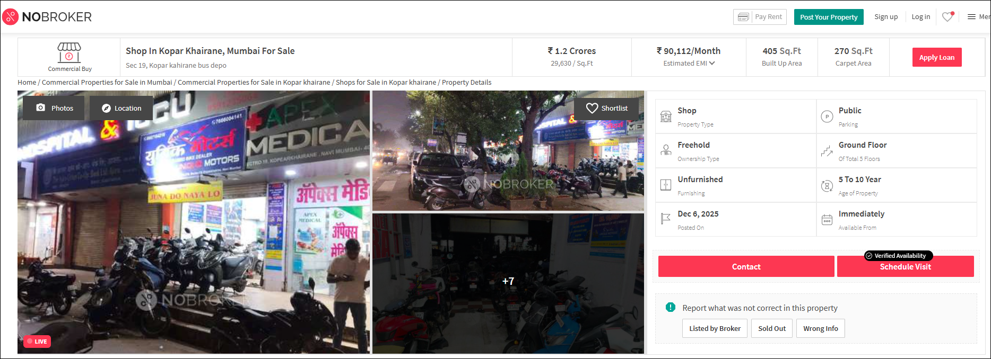

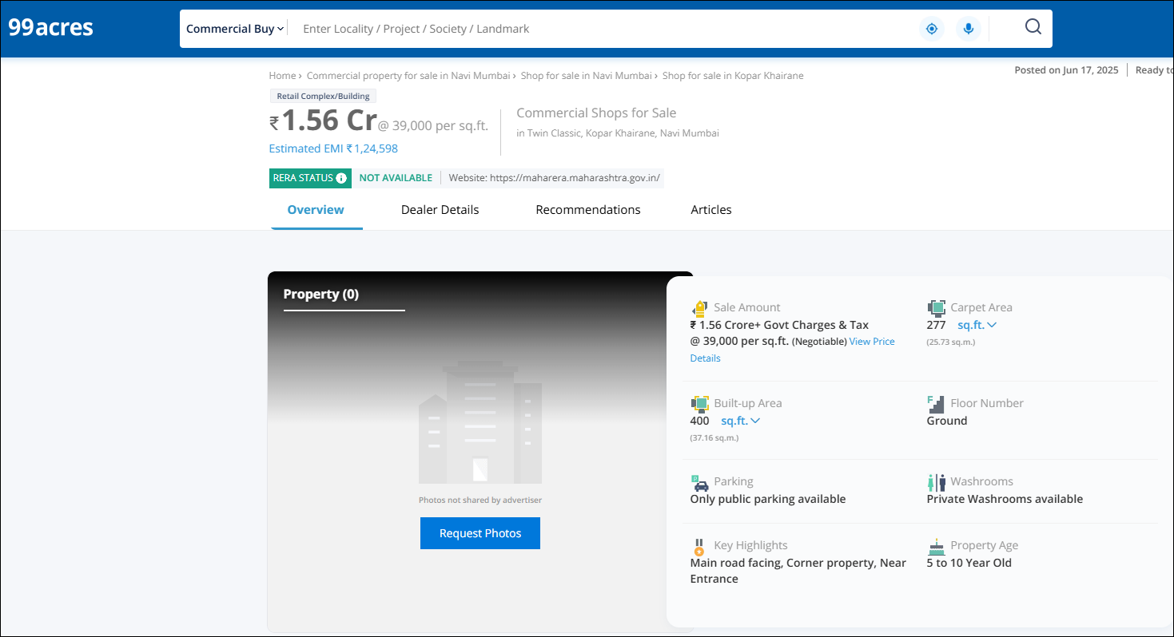

Property Document
